**Project Synopsis**

**Project Title:**

Movie Information & Data Analysis system

**Team Name**:

CodeMask

**Team Members**:

Nandini Bhargava

Shreyajyoti Dutta

Vikash Tyagi

**Objective:**

Our proposed project aims to **provide the user information about movies** depending on several parameters. It will also help the user to **get special insight** and reasonable outcome **to make decision** out of it.

**Technologies to be used:**

* Big Data Technologies(Apache Hadoop, Sqoop, Hive)
* Reporting & Visualization tool(Tableau)
* Web UI technologies(HTML, CSS, JS)

**Data Flow Diagram**

**Dataset**





**Reporting tool** to translate output into visualization

**Big Data ecosystem** where the data will be processed, analyzed & produce output

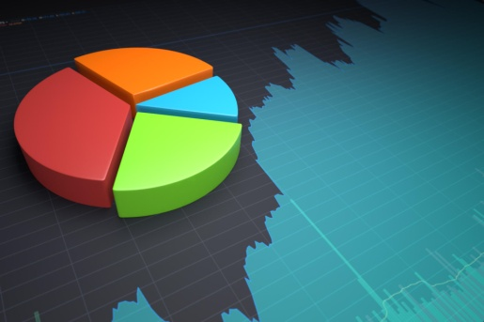

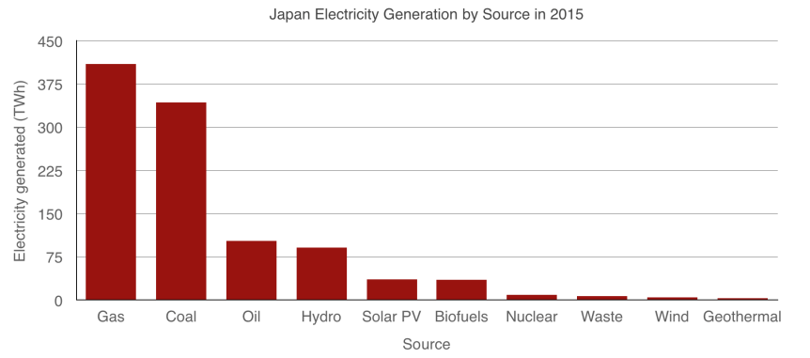

**Web interface** for the end user to access the result